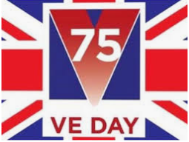
Victory in Europe Day
If we were in school, we would have been celebrating VE Day this week. Alas, we are not, however we hope that families will mark this momentous day at home.

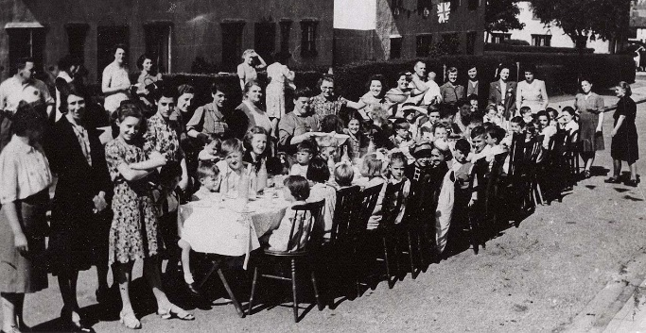
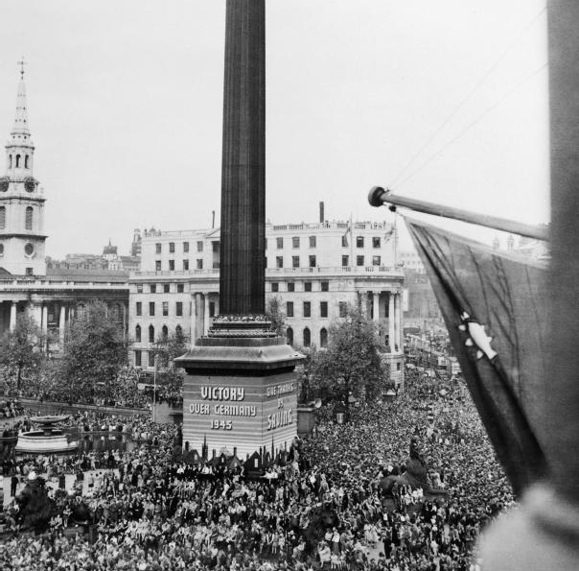
Victory in Europe Day (which is commonly known as VE Day) is a day celebrating the formal acceptance by the Allies of World War II of Nazi Germany's unconditional surrender of its armed forces on Tuesday, 8 May 1945.

When VE Day dawns on 8th May 2020, it will be 75 years since the guns fell silent at the end of the war in Europe. Years of carnage and destruction had ended and millions of people took to the streets and pubs to celebrate peace, mourn their loved ones and to hope for the future, but not forgetting those still in conflict until 15th August when it was announced that Japan had surrendered unconditionally to the Allies, effectively ending World War II.
This year, our May bank holiday has been moved to a Friday (as opposed to its usual Monday) as a way of marking the 75 years since VE Day. Below are some links to some websites and craft ideas, which you might like to have a look at whilst at home.
Newsround video:
https://www.bbc.co.uk/newsround/48201749
KS2 BBC Bitesize video
https://www.bbc.co.uk/teach/class-clips-video/history-ks2-ve-day/z7xtmfr
EYFS / KS1/2 Crafts with video and downloadable PDF's
https://www.bakerross.co.uk/craft-ideas/category/teachers/occasions-teachers/ve-day-occasions-teachers/

